**The Ships that Sailed**

Game Jam Project Brief

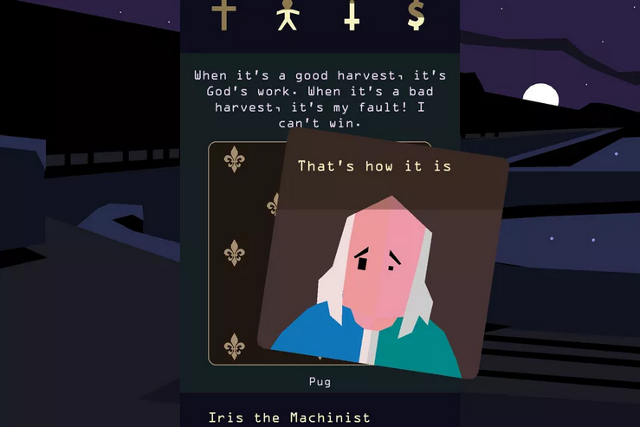

Video games—whether used as tools for literary adaptation, or standing on their own—are a unique medium through which to tell narratives that are impactful in distinctively medium-specific ways. This is true for games developed on all scales from text adventures to AAA titles. The advantage of small scale games is their adaptability: prototypes can be developed in a short amount of time, ideas can be tested, and game mechanics can be used to tell multiple distinctive stories within the same framework.

Your aim at this week’s Game Jam is to use the game framework provided to you, which is based on the mobile game *Reigns,* to develop your own interpretation of Scotland’s involvement in colonialism, its effect on the colonial empire and the wider world up to today.

**The Framework**

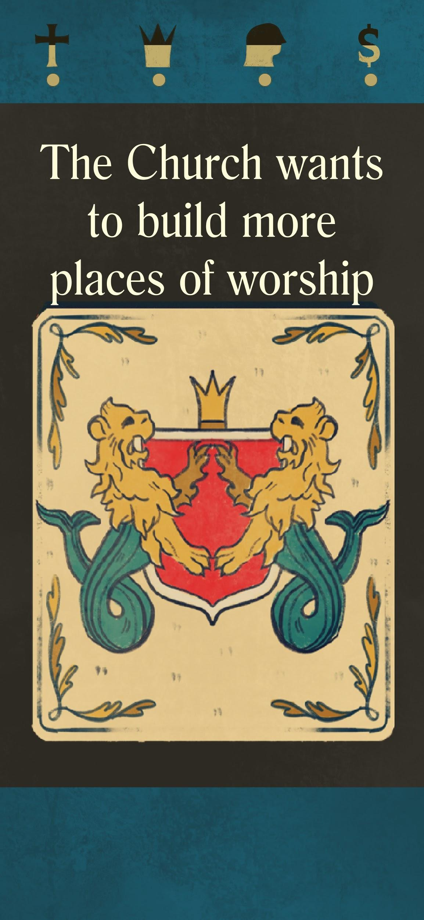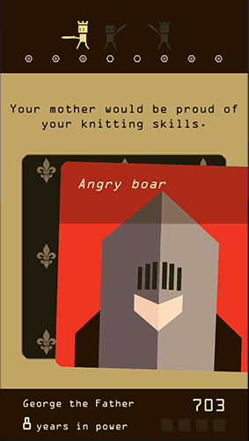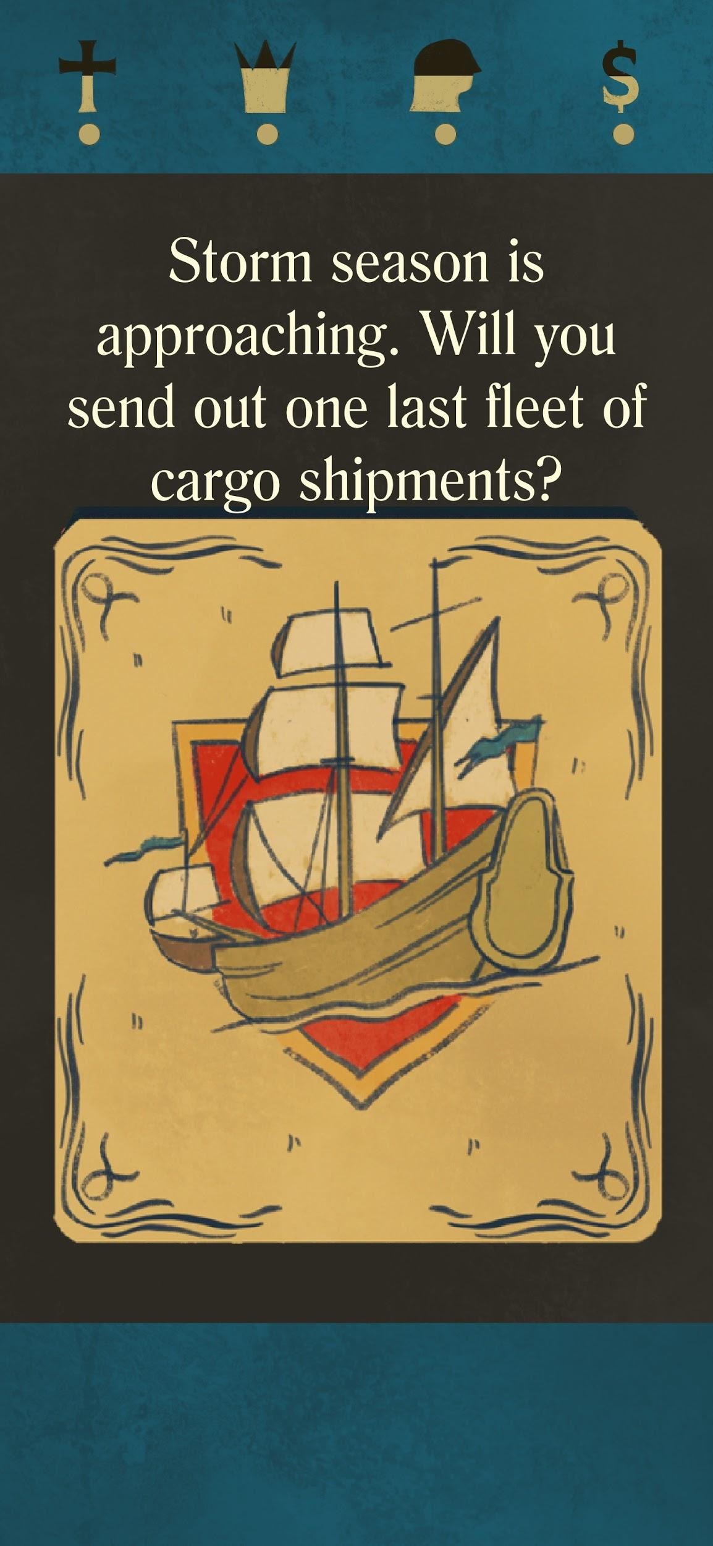

The game framework is based on a simple swipe right-swipe left mechanic. The player makes decisions while swiping in either direction, and the choice offered is displayed on the card as they hover over each direction (see images above). To see it in action and get a feel for how the game uses this mechanic to tell its narrative, we recommend playing the mobile game *Reigns.*

Each decision the player makes has a positive or negative effect on a number of variables (example variables are: Church, Crown, People and Money). Often, a single decision has both a positive and a negative effect at the same time. The balancing of these mechanics is up to you, and determining what variables you’d like to use is also up to your discretion: use them to reinforce the narrative!

**The Research**

During your stay in Dundee, you will visit several places that display or carry the legacy of Great Britain and Scotland’s role in colonial efforts. *The McManus* gallery and the *RSS Discovery* can both serve as inspiration for you to consider what effect colonialism had on the world, you should use this inspiration as you work together on your game.

**The Tools**

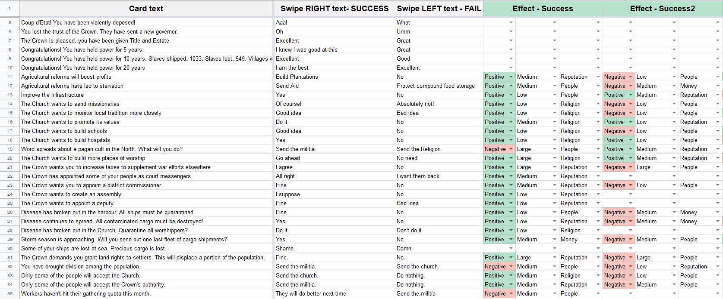

Your job during the game jam is to think about what kind of card texts would best tell your story. You will import these texts into a spreadsheet like you can see on the image above. Each card text will come with two swipe options, and the consequences are also your decision. The exact use of the sheet will be explained to you in greater detail once the jam starts.

**The deliverables**

What you are expected to do during this game jam is the following:

* Consider what colonialism and Scotland’s involvement in colonialism means--to you specifically, or to the world in general.
* Work together to write texts that create a narrative that reflects this.
* Import these texts into the spreadsheet.
* Build the game.